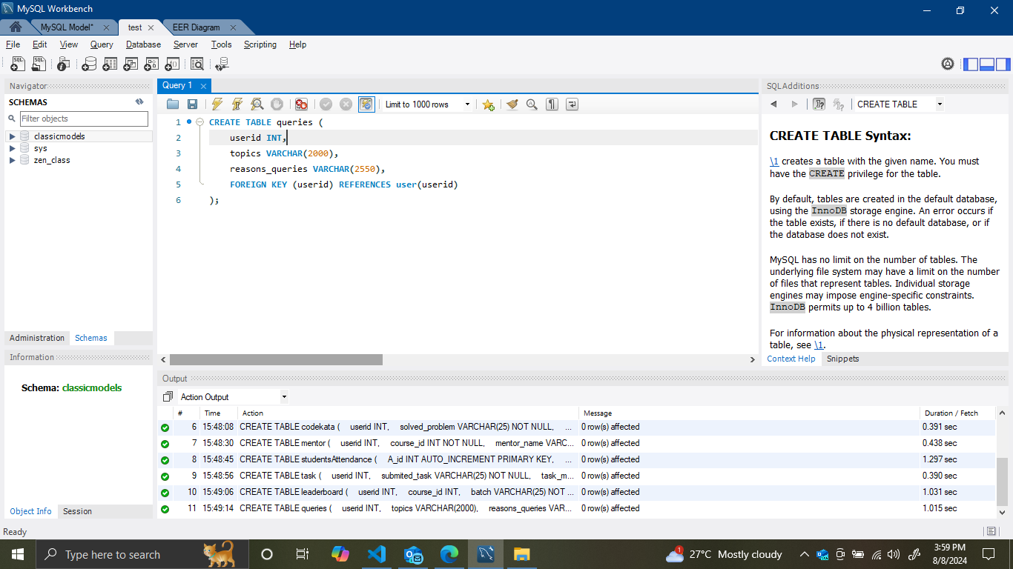

-- Create the 'guvi' database

CREATE DATABASE guvi;

-- Select the 'guvi' database to use

USE guvi;

-- Create the 'user' table

CREATE TABLE user (

userid INT PRIMARY KEY AUTO_INCREMENT,

username VARCHAR(25) UNIQUE,

useremail VARCHAR(255) UNIQUE,

usermobile VARCHAR(10) NOT NULL

);

-- Create the 'course' table

CREATE TABLE course (

course_id INT AUTO_INCREMENT PRIMARY KEY,

userid INT,

course_name VARCHAR(25),

course_duration VARCHAR(255),

course_fees VARCHAR(25),

FOREIGN KEY (userid) REFERENCES user(userid)

);

-- Create the 'admissions' table

CREATE TABLE admissions (

userid INT,

course_id INT,

admission_fees VARCHAR(25),

FOREIGN KEY (userid) REFERENCES user(userid),

FOREIGN KEY (course_id) REFERENCES course(course_id)

);

-- Create the 'codekata' table

CREATE TABLE codekata (

userid INT,

solved_problem VARCHAR(25) NOT NULL,

FOREIGN KEY (userid) REFERENCES user(userid)

);

-- Create the 'mentor' table

CREATE TABLE mentor (

userid INT,

course_id INT NOT NULL,

mentor_name VARCHAR(25),

FOREIGN KEY (userid) REFERENCES user(userid),

FOREIGN KEY (course_id) REFERENCES course(course_id)

);

-- Create the 'studentsAttendance' table

CREATE TABLE studentsAttendance (

A_id INT AUTO_INCREMENT PRIMARY KEY,

userid INT,

A_date DATETIME DEFAULT NOW(),

status BOOLEAN DEFAULT TRUE,

FOREIGN KEY (userid) REFERENCES user(userid)

);

-- Create the 'task' table

CREATE TABLE task (

userid INT,

submited_task VARCHAR(25) NOT NULL,

task_mark VARCHAR(25),

FOREIGN KEY (userid) REFERENCES user(userid)

);

-- Create the 'leaderboard' table

CREATE TABLE leaderboard (

userid INT,

course_id INT,

batch VARCHAR(25) NOT NULL,

submited_task VARCHAR(25) NOT NULL,

FOREIGN KEY (userid) REFERENCES user(userid),

FOREIGN KEY (course_id) REFERENCES course(course_id)

);

-- Create the 'queries' table

CREATE TABLE queries (

userid INT,

topics VARCHAR(2000),

reasons_queries VARCHAR(2550),

FOREIGN KEY (userid) REFERENCES user(userid)

);